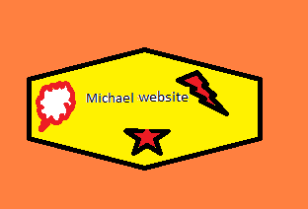

Table of contents

1. Brief description
2. Nav Bar
3. Colours section
4. Typography section
5. Branding section
6. Brief description:

* This website have a nav bar with and pages for Home, About

Me, Projects, Services, and GitHub. It have image, text, and a contact panel.

1. Nav Bar:

No mouse over nav bar

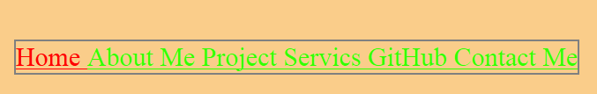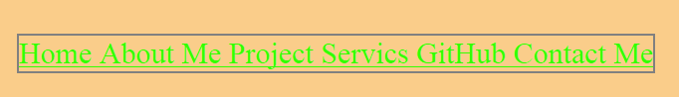

Mouse over nav bar home

When mouse over one of the link to a page it go red.

Example home till red

Go to pages

1. Colours section

Home page use a light orange and it swatches to yellow for the other page and for project detail pages it change to purple. Also for link when over change to red and green for the link.

Hex value: #609 for project detail, #F93 for links, #F00 hover, border gray, and for the other pages #FF0.

1. Typography section

Row 4

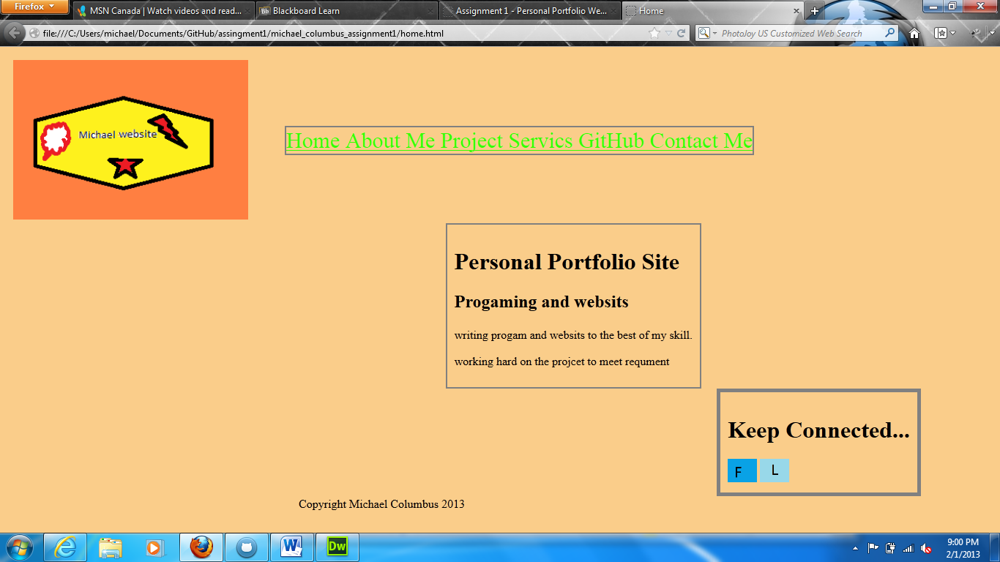

Row 2

Row 3

Row 1

|  |  |  |
| --- | --- | --- |
| Fonts | Size | color |
| calibri | 12 | black |
| Calibri bold | 16 | black |
| Calibri | 14 | black |
| calibri | 16 | Green |

1. Branding section

